Distraction off. Open sound on.
The new HD 620S breaks from the pack with contemporary tuning and soundstage that defy the closed headphone category.
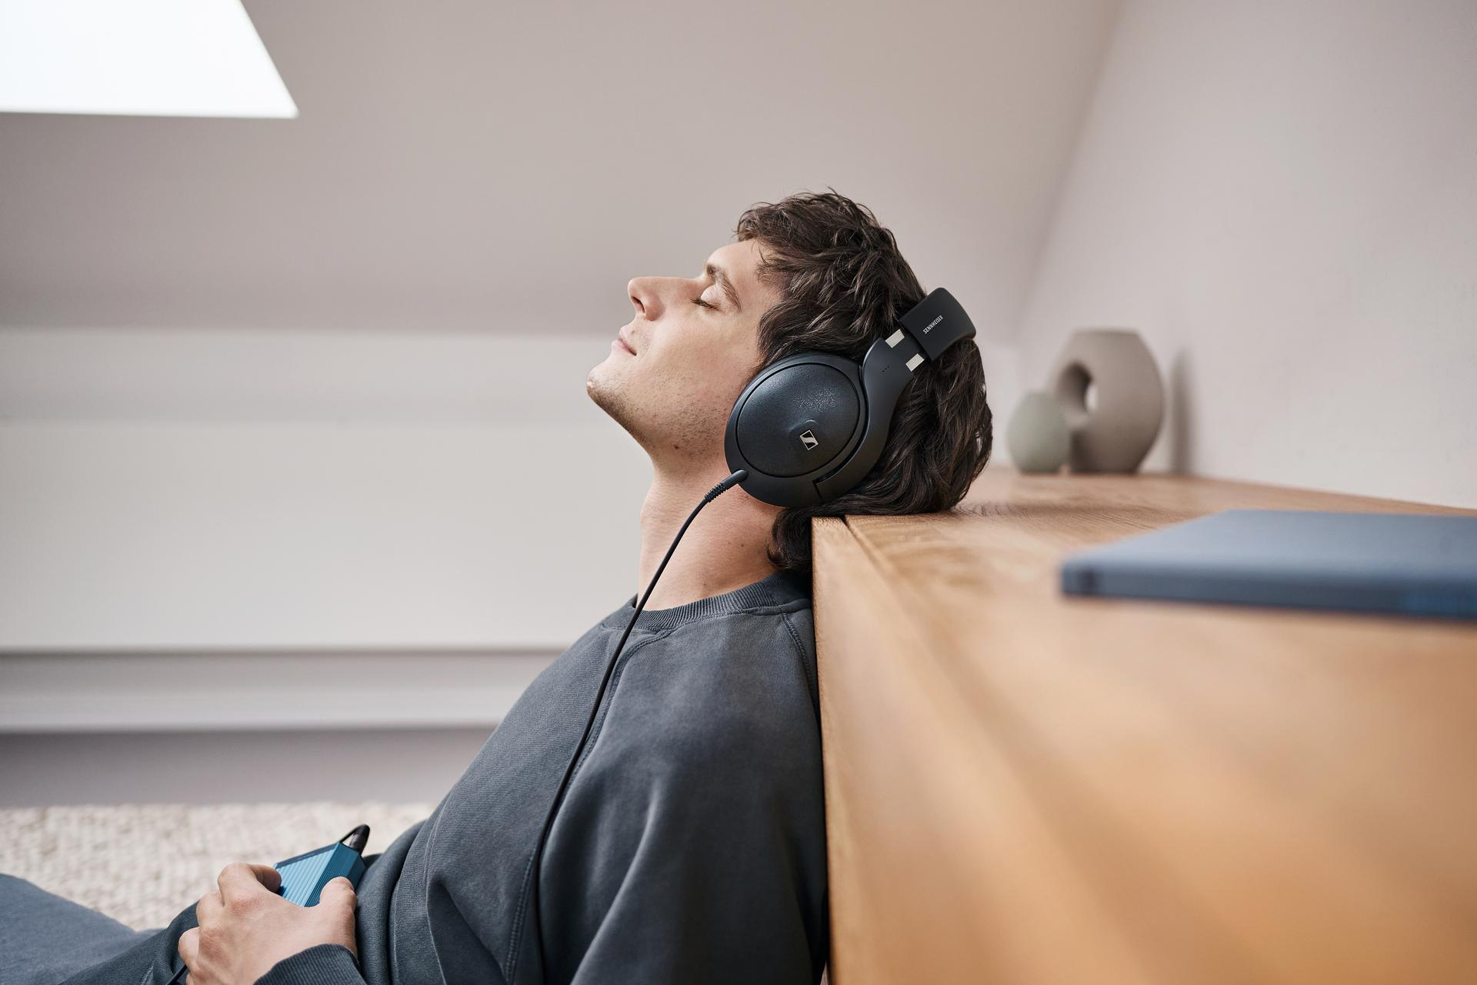
Marlow, United Kingdom – May 8, 2024 – The Sennheiser brand today unveiled the freshest member of the acclaimed HD 600 series, offering audiophiles a compelling take on closed headphones for private, reference listening without compromise.
“The hi-fi community has clamoured for a headphone with the best traits from our 600 series, yet isolates them from distractions at work, home, or in-between,” said Audiophile Product Manager Jermo Koehnke. “Not only does the HD 620S deliver on that promise, its immersive imaging and brilliant impulse response make it an exceptional listening experience for every situation where a higher level of performance matters.”
The family tree
At the heart of the HD 620S is a custom-tuned 42mm dynamic transducer made at the brand’s state-of-the-art Tullamore, Ireland transducer plant. It carries forward the smooth and effortless sound found in the open-back 600 family with a modern, airy signature that balances honesty with deep and articulate bass. Thanks to a high damping factor, the 150-ohm aluminium voice coil excels at speedy transients and well-defined instrument tails for punchy dynamics across the entire frequency spectrum—a boon for audiophiles and passionate gamers trying to consume as much detail as possible in a given moment.
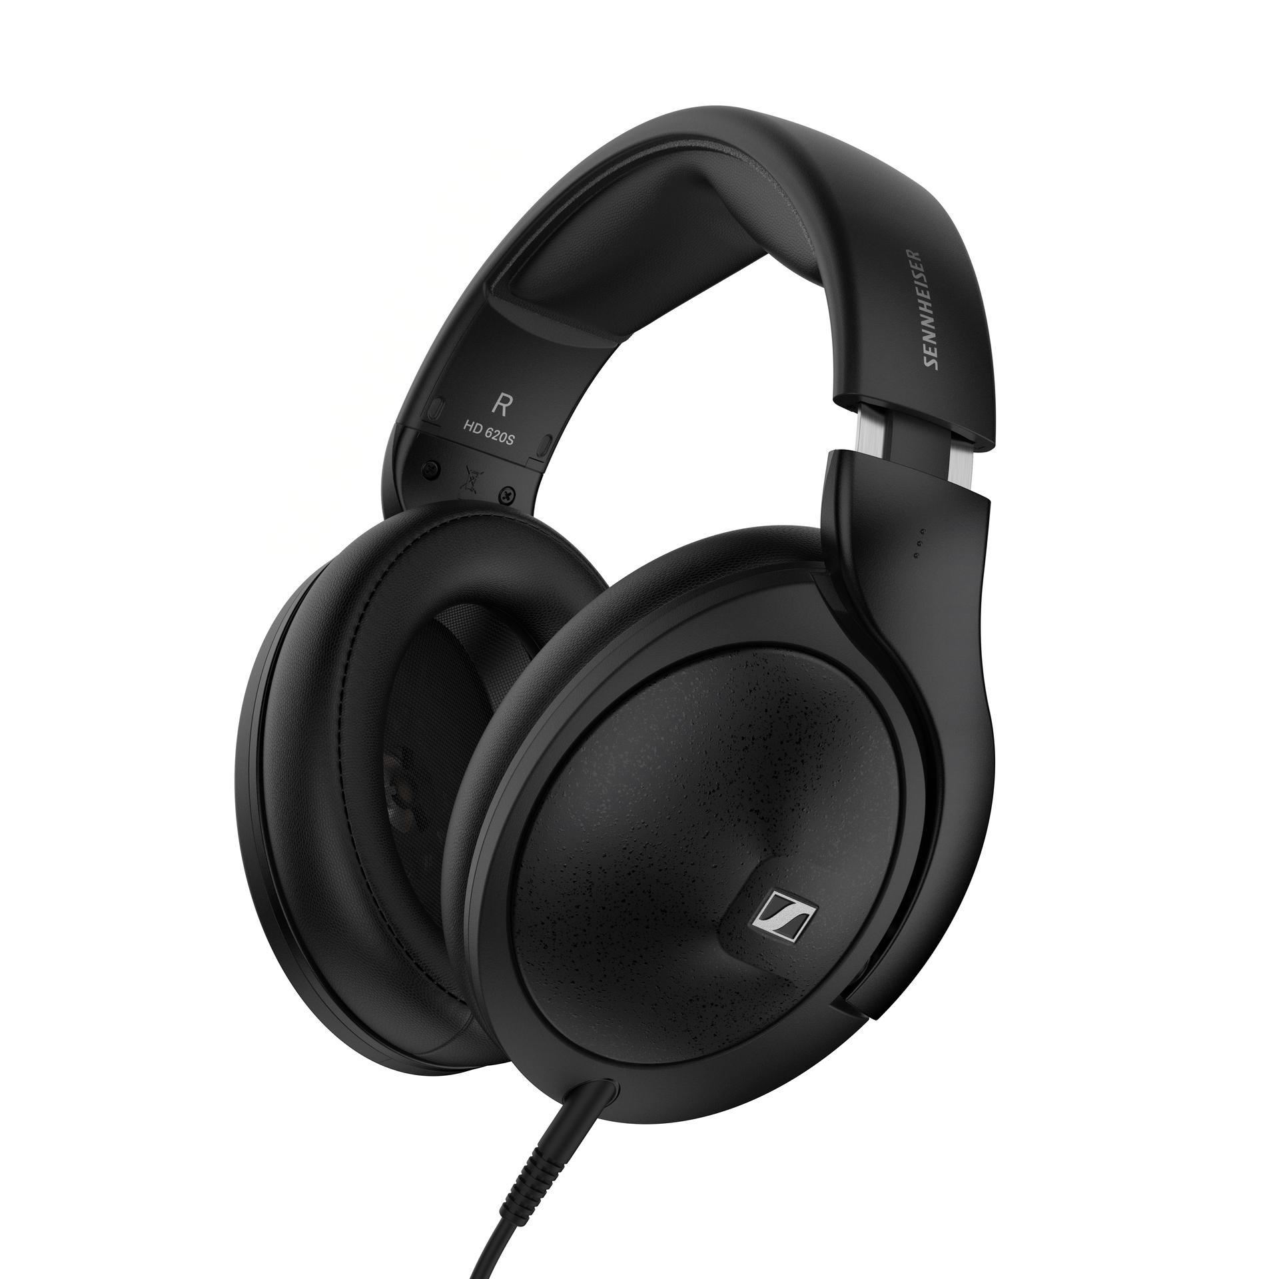
Situated in an iconic chassis beloved by audiophiles, gamers and streamers alike for its long-term wearing comfort, the HD 620S elicits a sense of confidence while providing an instant sweet spot. Metal appointments not only feel great to the touch but serve an acoustic purpose as well–the steel plate closing off the back volume is an efficient isolator that manages the internal reflections that cloud the purity of an acoustic signal within. The angled baffle is remarkably open to encourage the free movement of air, modelling the behaviour of open-back transducers while recreating the triangular imaging of a great loudspeaker setup in an expertly tuned room. This immersive presentation drops the listener into the centre of the action with impressive cue location, whether it is a rare live concert recording or massive online multiplayer showdown.
Case closed
Open headphones are an audio purists’ favourite, however closed headphones are invaluable for listening when isolation from the world around the listener is essential. Audiophiles are accustomed to trading the natural response and wide imaging of open headphones in order to keep distractions at bay, or from disturbing roommates, spouses and coworkers. No doubt, the HD 620S is a breakthrough in real-world performance, offering the dramatic soundstage they want absent the fatiguing, boxy sound associated with sealed cans.
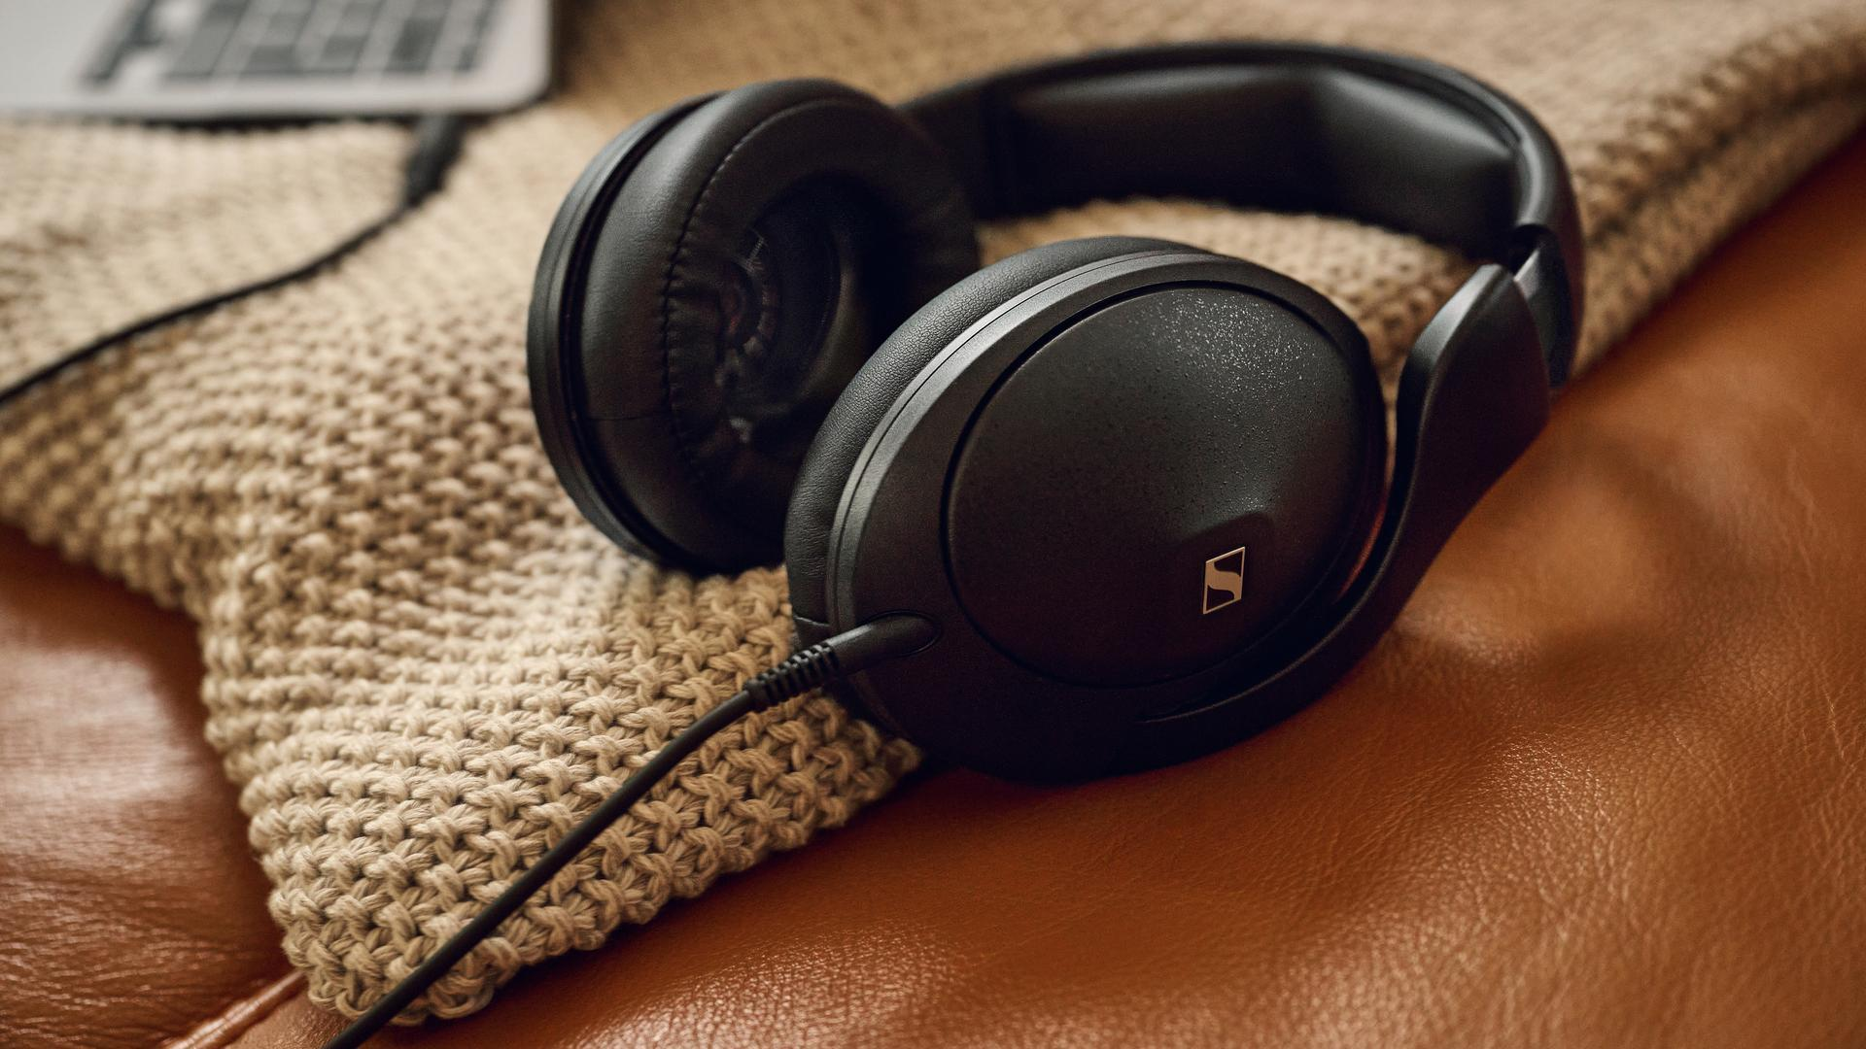
Pictured: The HD 620S is constructed of premium materials for lasting durability and comfort
You have new connections
The HD 620S was built to last with a metal-reinforced headband and earcup housings. An included storage pouch keeps dust at bay with ample space for the detachable cable too, for tidy keeping. The 1.8 metre cable terminates to a single-ended 3.5mm stereo plug with an integrated locking screw for the included 6.3mm adapter. Available this summer, an optional balanced 4.4mm cable will let audiophiles tap into a growing range of hi-fi devices supporting the popular connector. The HD 620S shares the twist-and-lock single-sided cable design with other Sennheiser headphones, giving the user plenty of aftermarket options including different lengths and an in-line microphone.

Pictured: The immersive, hyper-detailed presentation of the HD 620S is ideal for audiophiles and gamers alike
Pricing and availability
The HD 620S is currently available for pre-order, and begins shipping on June 6th 2024, and will be available from select retailers and at sennheiser-hearing.com with an RRP of £299.99 / €349.90.

About the Sennheiser brand
We live and breathe audio. We are driven by the passion to create audio solutions that make a difference. Building the future of audio and bringing remarkable sound experiences to our customers – this is what the Sennheiser brand has represented for more than 75 years. While professional audio solutions such as microphones, meeting solutions, streaming technologies and monitoring systems are part of the business of Sennheiser electronic GmbH & Co. KG, the business with consumer devices such as headphones, soundbars and speech-enhanced hearables became part of the Sonova Holding AG group of companies in 2022, who have licensed the Sennheiser trademark for this purpose.

www.sennheiser.com
www.sennheiser-hearing.com

About Sonova Consumer Hearing
Sonova Consumer Hearing offers premium headphones and hearables – primarily in the true wireless segment – as well as audiophile headphones, hearing solutions and soundbars under the Sennheiser brand. The business is part of the Sonova Group, a global leader in innovative hearing care solutions with headquarters in Switzerland and more than 17,000 employees worldwide.

Press contact

Milan Schlegel
PR and Influencer Manager EMEA, Sennheiser Consumer
Milan.Schlegel@sennheiser-ce.com

Harvard PR
Sennheiser UK&I PR agency
sennheiser@harvard.co.uk

